Department of Computer Science and Engineering (Data Science)
CSDS-A | Batch A2 (CSE - Data Science, Section A)
Attendance Magic: A Smart Geo-Fenced Attendance System with Live Challenge Verification
(Attendance Magic)
S.No. | Student name | Roll / hall ticket no.
1 | A.GREESHMA | 23K91A6706
2 | B.VINAY | 23K91A6740
3 | G.SRIRAM | 23K91A6757
4 | B.SAI KUMAR | 24K95A6704
Under the guidance of: [GUIDE NAME], [DESIGNATION]
METHODOLOGY, NOVELTY AND KEY CONTRIBUTIONS
This document describes how Attendance Magic works from end to end, why its algorithms were chosen, what is new in it compared with the base paper, and the contributions of the project. All figures are measured values from the project's own artefacts (docs/REPORT_FACTS.md).

1 Overall Methodology
The methodology is a verification chain rather than a learning pipeline: no model is trained. Two pre-trained models supply measurements (facial landmarks and face embeddings) and deterministic rules turn those measurements into decisions. The chain runs in the order of the check-in wizard, and each stage can end the check-in with a stored reason.
Table 1: Stages of the verification chain
Step | Input | Computation | Output / decision
1 Sign-in | username or roll number, password, X-Device-Id | PBKDF2-HMAC-SHA256 verify; JWT with device hash | token or 401
2 Eligibility | session, user, device hash | window, roll pattern, existing record, device record, device binding | eligible or reason
3 Location | latitude, longitude, accuracy | haversine distance; limit = radius + 15 m; accuracy <= 150 m | inside or reason
4 Challenge | neutral photo, challenge photo, challenge code | Face Mesh landmarks to yaw, pitch, roll, MAR, EAR; compare with thresholds | pass (score) or reason; retry up to 3
5 Face | the two photos | ArcFace 512-d embeddings; cosines: consistency, identity, duplicate | pass or reason
6 Record | all of the above | insert the attendance row and success attempt | record id; result screen

The same chain is available in two forms: services.run_pipeline executes it in one call (used by the demo script and tests) and the FastAPI wizard executes it step by step, keeping the intermediate state on the server. Both call the same functions of core/.

2 Dataset
There is no training dataset because no model is trained. Data enters the project in three ways.
Table 2: Data used in the project
Data | Source | Size | Use
LFW verification pairs | Labeled Faces in the Wild [9], pairs.txt protocol (research benchmark, downloaded from figshare, not redistributed) | 13,233 images, 5,749 people; 6,000 pairs (3,000 same, 3,000 different) in 10 folds of 600; 7,701 unique images used | Evaluate identity, duplicate and consistency thresholds
LFW stills | Same dataset | 1,000 random photos (seed 7); 157 identities with 10 or more photos | Neutral-frame, static replay, rotation and photo-bank attack experiments
Demo data | Created by scripts/seed_demo.py and capture_screenshots.py | 1 faculty and 6 student accounts, 2 sessions, 30 attempts logged in the live session | Screens, smoke test, walkthrough

Split. The LFW protocol is used exactly as published: the identity threshold is evaluated on all scored pairs, and the 10-fold accuracy (99.82% mean, standard deviation 0.22%) picks the best threshold on nine folds and tests on the tenth. The deployed thresholds (0.40 and 0.45) were set before the evaluation and were not tuned on it.
Licence and privacy. LFW images are news photographs of public figures, distributed for research on face recognition. They are used here only to evaluate the verification chain and, with their file names anonymised, as stand-ins for student photographs in the demo screenshots; they are not redistributed with the project. No student photographs were collected.

3 Preprocessing
- Image decoding. decode_image decodes the uploaded bytes with OpenCV and shrinks any image whose longer side exceeds 1,280 px (area interpolation) to keep inference fast on phone photos.
- Colour order. Images are kept in BGR for InsightFace and converted to RGB for MediaPipe.
- Single-face rule. Face Mesh must find exactly one face in each photo; InsightFace must find one face, or a second face whose width is at most half that of the largest face.
- Neutral frame. The first photo must be frontal (|yaw| <= 0.10) and the mouth closed (MAR <= 0.25), so that later changes are measured from a known pose.
- Mirroring. Selfie cameras mirror the image; with AM_CAMERA_MIRRORED = true the left and right challenges flip their sign so that 'turn left' refers to the student's left.
- Embedding normalisation. Embeddings are L2-normalised before storage and before every comparison, so a dot product is a cosine similarity.
- Roll patterns. Allowed roll numbers are upper-cased and matched with fnmatch; an explicit list (no wildcards) is also used to list absentees.
On the LFW sample the neutral-frame check accepted 329 of 1,000 photos (32.9%); it rejected 499 as not frontal, 92 for several faces, 79 for an open mouth and 1 for no face. The single-face rule of the recogniser rejected 1,208 of 7,701 LFW images (15.7%), 1,197 of them as 'more than one face'.

4 Algorithm Choice and Justification
Table 3: Algorithm choices
Decision | Chosen | Alternatives | Justification
Liveness approach | Active random challenge on landmark metrics | Passive texture / learned anti-spoofing [5], [12]; blink detection [11] | No extra model, works on any camera, thresholds are transparent, and the unpredictable action defeats a prepared photo; its weaknesses are measured (Chapter 8)
Landmarks | MediaPipe Face Mesh [8] (legacy solutions API, 468 points) | dlib 68 points, 3-D head-pose solvers | Fast on CPU, bundled model, includes lips and eyelids for MAR and EAR
Recogniser | InsightFace buffalo_l (SCRFD + ArcFace R50) [6], [7] | LBPH [1], FaceNet [13] | No per-student training; margin-trained embeddings; one reference photo; high verification accuracy (Section 8.2)
Similarity | Cosine on L2-normalised 512-d embeddings | Euclidean distance, classifier head | Standard for ArcFace; a dot product; thresholds are interpretable
Distance | Haversine on a sphere [14] | Vincenty [15] | 0.47% error (0.35 m at the 75 m limit) is far below GPS noise; far simpler
Tokens | JWT HS256 with a device claim [16] | Server sessions | Stateless API; a stolen token fails on another device
Password hash | PBKDF2-HMAC-SHA256, 200,000 iterations [17] | bcrypt, Argon2 | Available in the Python standard library; no extra dependency

5 Mathematical Formulation

5.1 Geo-fence
For a student at latitude phi2 and longitude lambda2 and a centre at phi1 and lambda1 (radians), the great-circle distance on a sphere of radius R = 6,371,000 m is
a = sin^2((phi2 - phi1)/2) + cos(phi1) cos(phi2) sin^2((lambda2 - lambda1)/2)
d = 2 R asin( sqrt(a) )

The check-in is accepted if the reported accuracy is at most 150 m and d <= r + t, where r is the session radius (60 m by default) and t = 15 m is the tolerance. Against the ellipsoidal (Vincenty) distance at latitude 17.385 degrees the spherical formula is off by a constant 0.469%, which is 0.35 m at 75 m and 4.7 m at 1 km.

5.2 Landmark metrics
Let p_i be the 2-D landmark with Face Mesh index i, and x_L, x_R the x-coordinates of the cheek landmarks 234 and 454. With nose tip 1, chin 152, eye corners (33, 133) and (263, 362), eyelids (159, 145) and (386, 374) and lip landmarks 13, 14, 61, 291:
yaw = (x_nose - min(x_L, x_R)) / |x_R - x_L| - 0.5
pitch = (y_nose - y_eyes_mid) / (y_chin - y_eyes_mid)
roll = atan2(y_Reye - y_Leye, x_Reye - x_Leye) (degrees)
MAR = |p13 - p14| / |p61 - p291|
EAR = mean over both eyes of |top - bottom| / |outer - inner|

A frontal, mouth-closed face has yaw near 0 (measured standard deviation 0.053 on accepted LFW frames), pitch near 0.35, MAR near 0.09 and EAR near 0.28.

5.3 Challenge decision
With the neutral frame n and the challenge frame c, and s = -1 for mirrored cameras and +1 otherwise, the measured quantity m is:
Table 4: Challenge decision rules
Challenge | Measured quantity m | Pass if | Score
Turn left / right | s (yaw_c - yaw_n) / -s (yaw_c - yaw_n) | m >= 0.12 | min(1, m/0.12)
Look up / down | -(pitch_c - pitch_n) / (pitch_c - pitch_n) | m >= 0.08 | min(1, m/0.08)
Tilt left / right | s (roll_c - roll_n) / -s (roll_c - roll_n) | m >= 12 degrees | min(1, m/12)
Open mouth | MAR_c | m >= 0.35 | min(1, m/0.35)
Close eyes | 2 x 0.18 - EAR_c | EAR_c <= 0.18 | min(1, m/0.18)

5.4 Face decision
With L2-normalised embeddings f1 (neutral photo), f2 (challenge photo), e (enrolled) and g_j (faces already recorded in the session), and cos(a, b) = a . b:
consistent = cos(f1, f2) >= 0.45
identity = cos(f1, e) >= 0.40
unique = max_j cos(f1, g_j) < 0.45
pass = consistent and identity and unique

The three thresholds are environment settings (AM_FRAME_CONSISTENCY_THRESHOLD, AM_IDENTITY_THRESHOLD, AM_DUPLICATE_THRESHOLD). Section 8.2 shows how they sit between the same-person and different-person similarity distributions.
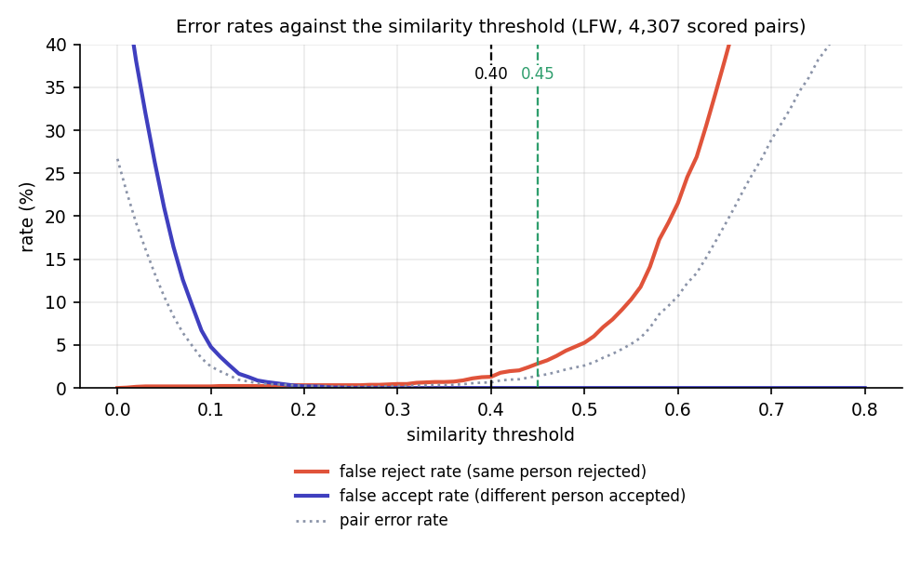
Fig. 1: Acceptance of same-person and different-person pairs against the cosine threshold (LFW pairs)

6 Models, Configuration and Training
No model is trained in this project. There is therefore no training set, no loss curve, no epochs and no validation split; the documents of the earlier reviews that listed 'training configuration' refer to the configuration of the verification chain given below. Both models are used as published:
Table 5: Pre-trained models
Model | Role | Details
MediaPipe Face Mesh 0.10.21 (legacy solutions API) | Landmarks for liveness | static_image_mode, up to 3 faces, refine_landmarks on, min detection confidence 0.5; 468 landmarks; bundled model; CPU
InsightFace buffalo_l (insightface 2.0, ONNX Runtime 1.31, CPUExecutionProvider) | Detection and recognition | detection (SCRFD) and recognition (ArcFace ResNet-50) modules only; det_size 640 x 640; 512-d embeddings; about 280 MB download on first use

Table 6: Configuration of the verification chain
Setting | Default | Environment variable
Geo-fence radius / tolerance / accuracy limit | 60 m / 15 m / 150 m | AM_DEFAULT_RADIUS_M, AM_GEOFENCE_TOLERANCE_M, AM_MAX_GPS_ACCURACY_M
Challenge thresholds | yaw 0.12, pitch 0.08, roll 12 deg, MAR 0.35, EAR 0.18 | AM_LIVENESS_YAW_DELTA, _PITCH_DELTA, _ROLL_DEG, _MAR, _EAR
Neutral frame | |yaw| <= 0.10, MAR <= 0.25 | (constants in config.py)
Face thresholds | consistency 0.45, identity 0.40, duplicate 0.45 | AM_FRAME_CONSISTENCY_THRESHOLD, AM_IDENTITY_THRESHOLD, AM_DUPLICATE_THRESHOLD
Enrolment required | true | AM_REQUIRE_ENROLLMENT
Devices per student | 1 | AM_MAX_DEVICES_PER_STUDENT
JWT validity / password iterations | 120 min / 200,000 | AM_JWT_EXPIRY_MINUTES / (constant)
Liveness tries | 3 | (constant in ui/student.py)
Camera mirrored | true | AM_CAMERA_MIRRORED
Time zone / database | Asia/Kolkata / SQLite file | AM_TIMEZONE / DATABASE_URL

7 Base Paper Analysis
Dharmaraj K B, Dhanushree C N, Revanth H V, Shashank N and Tejaswini P M, "Real-Time Student Face Recognition Attendance System Using AI," IARJSET, vol. 12, no. 5, pp. 1067-1072, May 2025, DOI 10.17148/IARJSET.2025.125183 [1].

7.1 Problem and approach
The paper proposes to automate classroom attendance with face recognition so that students are identified as they appear in front of a webcam. During registration each student's face is captured from several angles and lighting conditions (the implementation section states 25 to 30 images per student, and the results section 50 or more) and labelled with the student ID. A recogniser is trained from these images; when a lecture starts, the webcam scans for faces and, when a match exceeds a confidence threshold, the attendance (student ID, date, time, subject) is logged.

7.2 Method
Table 7: Method of the base paper
Component | What the paper uses
Face detection | Haar cascade classifier on the live webcam frame; the face is cropped and passed on
Face recognition | Local Binary Pattern Histogram (LBPH) recogniser trained from the registration images; a model file (.yml) is saved
Interface | Python and Tkinter desktop GUI: select subject, start recognition, view attendance, manual entry when recognition fails
Feedback | pyttsx3 text-to-speech announces recognised students and errors
Storage | Subject-wise, timestamped CSV files (or a relational database)
Libraries | Python, OpenCV, Tkinter, NumPy, Pandas, Matplotlib (attendance charts), pyttsx3

7.3 Reported results
Table 8: Results reported in the base paper
Measure | Reported value
Recognition accuracy | About 92-95% under well-lit, frontal conditions
False negatives | About 5-8%, mostly poor lighting or angled faces
False positives | 0%: unregistered faces were shown as 'Unknown'
Recognition speed | Under 2 seconds per face; image capture about 1.5 s; training 2-5 s for 10+ students
Hardware | Basic hardware without external servers or a GPU

The paper does not state how many students were tested, how many test images were used or how the accuracy was computed, so the figures can be taken as indicative of a small classroom test rather than as a benchmark.

7.4 Strengths
- Simple and inexpensive: the system runs on a laptop with no GPU and no server.
- A manual-entry fallback and spoken feedback make it usable by non-technical staff.
- Attendance is stored per subject with timestamps and can be charted.
- The literature survey inside the paper (Haar+LBPH, CNN+SVM/KNN, VGG16/ResNet transfer learning, FaceNet+MTCNN, end-to-end CNN with a GUI) gives a clear picture of face-recognition choices.

7.5 Limitations (our reading)
- Identity only. Nothing checks that the face is live. The abstract mentions resistance to impersonation, but the method section describes no liveness, anti-spoofing or challenge step, so a photograph that is recognised would be accepted.
- No location or time-window logic. Attendance is whatever the webcam in the room sees; there is no session link, no geo-fence and no device or roll restriction.
- No duplicate-identity logic. Identification is per frame; there is no comparison of new faces with those already recorded in the session.
- Lighting and pose sensitivity. The paper itself reports misses under poor lighting or angled faces, and LBPH is a texture method that is weaker than modern embedding models on look-alike or masked faces.
- Training per student. 25-50 images per student and a retraining step are needed whenever a student is added; embedding models need one reference photo.
- Single machine. A Tkinter application on the classroom computer: no student-side access, no web interface and no remote reporting.

7.6 What Attendance Magic adopts and changes
Attendance Magic adopts the idea of face-based identity verification and the practical choices of local, GPU-free operation and a manual-friendly records view. It replaces the Haar+LBPH pipeline by pre-trained ArcFace embeddings [6] (one reference photo, no retraining) and adds what the base paper lacks: a time-bound session, a geo-fence, a random live challenge, a per-session duplicate check, device binding and an audit log, all delivered through a browser on the student's own phone.

8 Key Contributions
Measured values quoted below are taken from the project's own experiments (Chapter 8).
1. One time-bound check-in that combines six independent checks (eligibility, device, geo-fence, live challenge, identity and duplicate-face) in a fixed, logged sequence, where the base paper's system performs identity only.
2. A random live facial challenge built on Face Mesh landmark metrics (yaw, pitch, roll, mouth and eye aspect ratios) with eight actions, a neutral-frame check and a three-try lock. A single stolen photo passes none of seven challenges and 8.2% of 'close eyes'.
3. A per-session duplicate-face check and device binding that blocks one person marking several roll numbers; at threshold 0.45 a second capture of an already recorded face is detected 97.2% of the time on LFW pairs.
4. Measured thresholds. On the LFW verification protocol the deployed identity threshold (0.40) accepts 98.7% of same-person pairs and none of 2,166 different-person pairs (AUC 0.999).
5. An honest attack evaluation. The project measures where its own liveness check fails (rotated photo, photo bank), so the limits are known rather than assumed.
6. A complete, reproducible application: React 19 front end, FastAPI back end (27 endpoints), SQLite storage, Excel export, 23 pytest tests, a 41-check API smoke test and scripts that regenerate every screenshot, diagram and measurement.

8.1 Novelty against the base paper
Table 9: Novelty of Attendance Magic compared with the base paper
Aspect | Base paper [1] | Attendance Magic
Recognition | Haar cascade + LBPH trained on 25-30 images per student | Pre-trained ArcFace embeddings from one reference photo
Spoof resistance | None described | Random live challenge (8 actions), three tries, then lock
Location | None | GPS geo-fence with radius, tolerance and accuracy gate
Identity abuse | None described | Duplicate-face scan in the session; device binding; roll patterns
Time control | Instructor starts and stops scanning | Time-bound sessions with unique link, QR code and close
Records | CSV files | Database with attempt log; Excel with absentees and verification log
Evidence | ~92-95% recognition in classroom tests (size not stated) | Thresholds and attacks measured on LFW; tests and timings reported

